TASK 3 — ALERT TRIAGE PRACTICE

Objective: Learn how SOC analysts validate alerts, identify false positives, and escalate real threats.
Tools: Wazuh, VirusTotal, AlienVault OTX.

Step-by-Step Process

Traige- Gathering information whenever any alert come to the SIEM tool first thing we will assign the ticket to ourselves. Later we create Instant ticket in the ticket in the ticketing tool. Then will identify the what type of incident that we received.
“Triage means Gathering information related to IOC & IOA”
IOC (indicator of Compromise), IOA (Indicator of attacker)
Gathering information of IOC & IOA like any Alert is received will identify the IP address through which IP Address that Alert is received.
Ip address-Source IP and Destination IP
- Will identify the Location
- Will identify end user system or server
- Will identify whether it is Physical or virtual machines
- ole years will do this WOL.
- Attacker IP Address
- Will check the TTP (Tactics, Techniques and procedures)
- Attacker location
- File name
- Payload
- File size
- Action
- File category
- Payload
- Hash value

IOC - Indicators of compromise

- Victim IP or Destination IP
- Hostname or computer name or FQDN or system name
- Location
- Identification of whether it is end system or server
- File name
- File size
- File cat
- Hash Value

IOA-Indicator of Attack

- Attacker IP
- Location
- TTP
Step 1 — Receive Alert in Wazuh
You receive an alert generated by Wazuh:
Example Alert:
“Multiple failed SSH login attempts detected on Server-X.”
Record the details:

Alert ID | Description | Source IP | Priority | Status
002 | Brute-force SSH Attack | 192.168.1.100 | Medium | Open

Step 2 — Verify Log Details
Check /var/log/auth.log or Wazuh event logs.
Look for patterns:
- Repeated login failures
- Failed authentication attempts
- Username patterns (root/admin/test)
Example Log Snippet:

>>>Failed password for root from 192.168.1.100 port 44512 ssh2(linux)
>>>Failed password for admin from 192.168.1.100 port 44512 ssh2(windows)

Step 3 — Threat Intelligence Validation
3.1 Check IP Reputation (AlienVault OTX) or AbuseIPDB
Search for: 192.168.1.100
You may find:
- IP flagged for SSH brute-force
- Part of known botnet
- Past malicious activity

3.2 Check File Hash (If any) Using VirusTotal
If alert includes a suspicious binary:
>> sha256sum malicious_file.exe
Search hash on VirusTotal.

Step 4 — Determine if Alert is True Positive or False Positive
True Positive Indicators:
- IP found malicious in OTX
- Repeated failed login attempts
- Login attempts to privileged accounts
- Attempts outside normal business hours
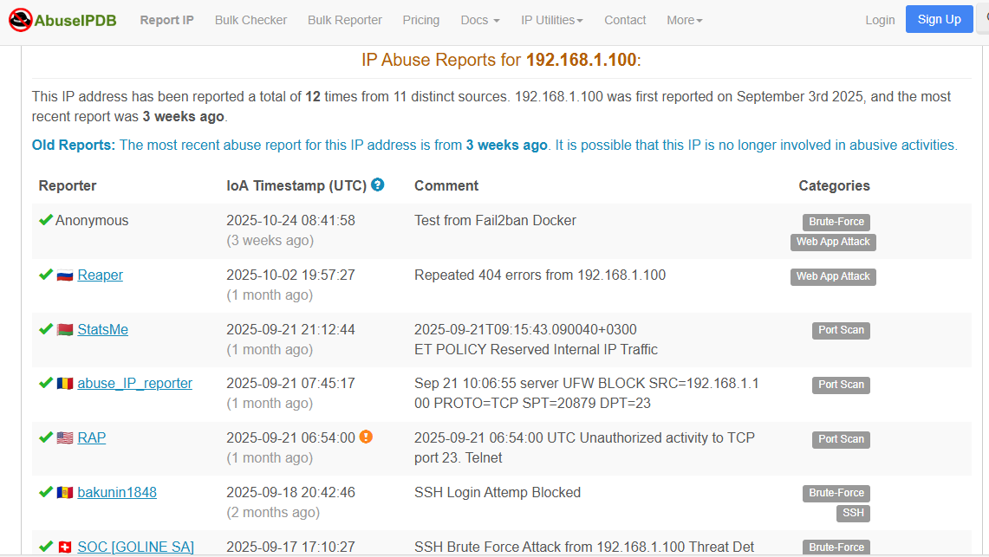

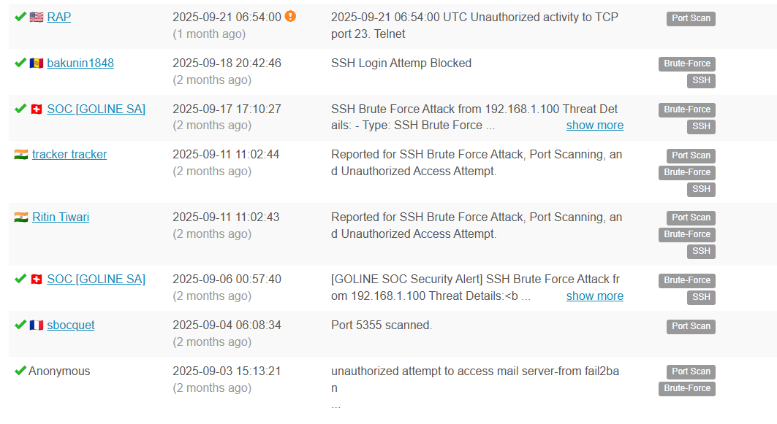
False Positive Indicators:
- Internal vulnerability scanner
- IT admin performing testing
- System misconfiguration

Step 5 — Document Findings
“Investigation confirmed repeated SSH login failures from IP 192.168.1.100. AlienVault OTX and AbuseIPDB reports this IP as part of a known brute-force campaign. The activity is a true positive. Immediate action required: block source IP, enforce SSH hardening, and enable MFA on affected systems.”

